**WEEK2_PLSQL_HANDSON**

**Exercise 1: Control Structures**

**Scenario 1:** The bank wants to apply a discount to loan interest rates for customers above 60 years old.

* + **Question:** Write a PL/SQL block that loops through all customers, checks their age, and if they are above 60, apply a 1% discount to their current loan interest rates.

**Scenario 2:** A customer can be promoted to VIP status based on their balance.

* + **Question:** Write a PL/SQL block that iterates through all customers and sets a flag Is VIP to TRUE for those with a balance over $10,000.

**Scenario 3:** The bank wants to send reminders to customers whose loans are due within the next 30 days.

* + **Question:** Write a PL/SQL block that fetches all loans due in the next 30 days and prints a reminder message for each customer.

**Step1: Create the CUSTOMERS table:**

CREATE TABLE CUSTOMERS_FINAL (

    CustID NUMBER,

    Name VARCHAR2(50),

    Age NUMBER,

    Balance NUMBER,

    IsVIP VARCHAR2(5),

    InterestRate NUMBER

);

**Step 2: Create Loan Table:**

Create new LOAN table

CREATE TABLE LOANS_FINAL (

    LoanID NUMBER,

    CustID NUMBER,

    DueDate DATE

);

**Step3: Insert sample data:**

 INSERT INTO CUSTOMERS_FINAL VALUES (1, 'Deepika', 20, 20000, 'FALSE', 10);

    INSERT INTO CUSTOMERS_FINAL VALUES (2, 'Nandini', 22, 8000, 'FALSE', 12);

    INSERT INTO CUSTOMERS_FINAL VALUES (3, 'Suvarna', 65, 20000, 'FALSE', 9);

    INSERT INTO CUSTOMERS_FINAL VALUES (4, 'Ravi', 70, 15000, 'FALSE', 11);

    INSERT INTO LOANS_FINAL VALUES (101, 1, SYSDATE + 15);

    INSERT INTO LOANS_FINAL VALUES (102, 2, SYSDATE + 40);

    INSERT INTO LOANS_FINAL VALUES (103, 3, SYSDATE + 5);

**Scenario 1: The bank wants to apply a discount to loan interest rates for customers above 60 years old.**

BEGIN

   FOR rec IN (SELECT CustID FROM CUSTOMERS_FINAL WHERE Age > 60) LOOP

      UPDATE CUSTOMERS_FINAL

      SET InterestRate = InterestRate - 1

      WHERE CustID = rec.CustID;

   END LOOP;

   DBMS_OUTPUT.PUT_LINE('Scenario 1: Interest discount applied.');

END;

/

SELECT * FROM LOANS_FINAL;

**Output for Scenario 1:**

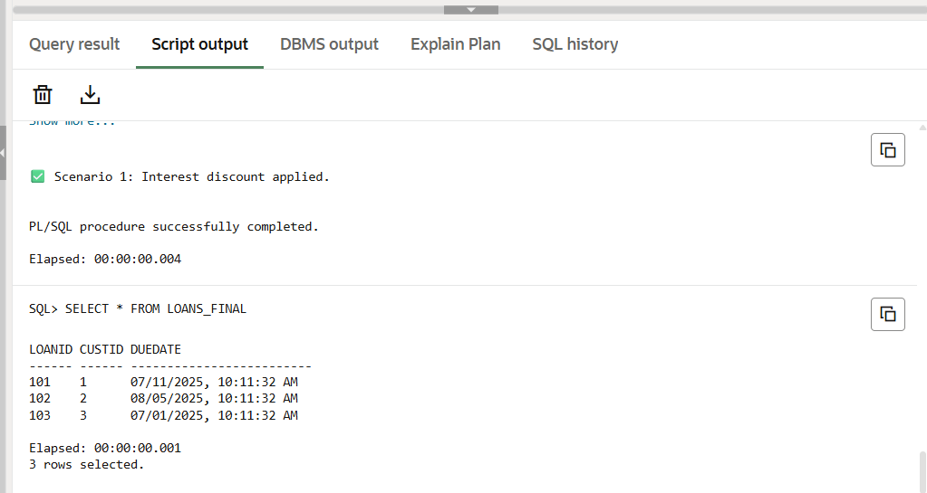

**Scenario 2: A customer can be promoted to VIP status based on their balance.**

BEGIN

   FOR rec IN (SELECT CustID FROM CUSTOMERS_FINAL WHERE Balance > 10000) LOOP

      UPDATE CUSTOMERS_FINAL

      SET IsVIP = 'TRUE'

      WHERE CustID = rec.CustID;

   END LOOP;

   DBMS_OUTPUT.PUT_LINE('✅ Scenario 2: VIP status updated.');

END;

/

SELECT * FROM CUSTOMERS_FINAL;

**Output for Scenario2:**

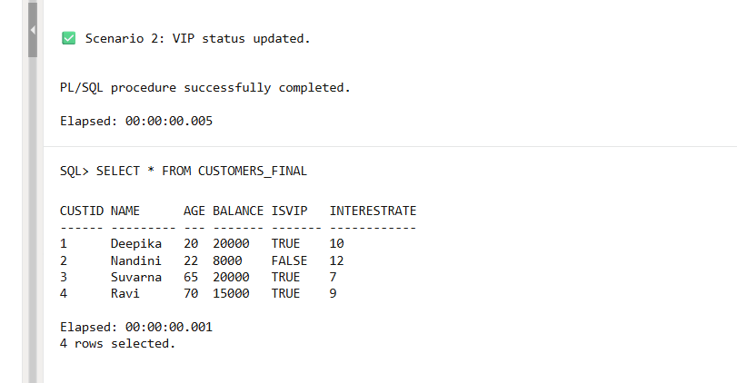

**Scenario 3: The bank wants to send reminders to customers whose loans are due within the next 30 days.**

BEGIN

FOR rec IN (

SELECT L.LoanID, C.Name, L.DueDate

FROM LOANS_FINAL L

JOIN CUSTOMERS_FINAL C ON C.CustID = L.CustID

WHERE L.DueDate <= SYSDATE + 30

) LOOP

DBMS_OUTPUT.PUT_LINE('Reminder: Loan ID ' || rec.LoanID ||

' for customer ' || rec.Name ||

' is due on ' || TO_CHAR(rec.DueDate, 'DD-MON-YYYY'));

END LOOP;

END;

/

SELECT * FROM CUSTOMERS_FINAL;

SELECT * FROM LOANS_FINAL;

**Output for Scenario3:**

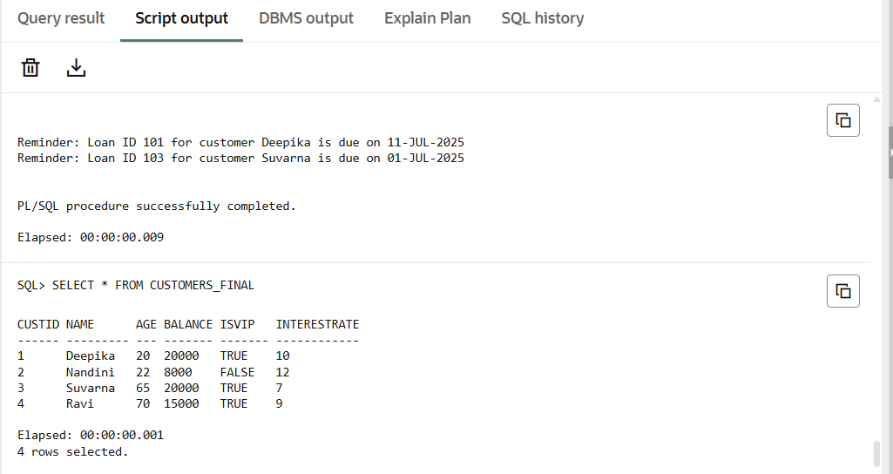

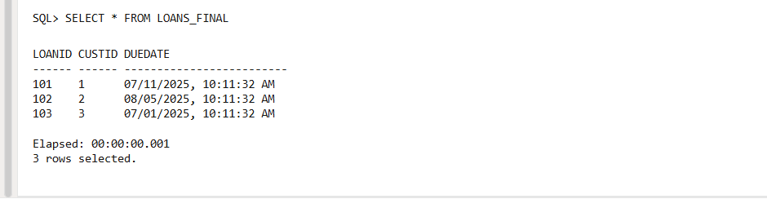

**Exercise 3: Stored Procedures**

Scenario 1: The bank needs to process monthly interest for all savings accounts.

* + Question: Write a stored procedure ProcessMonthlyInterest that calculates and updates the balance of all savings accounts by applying an interest rate of 1% to the current balance.

Scenario 2: The bank wants to implement a bonus scheme for employees based on their performance.

* + Question: Write a stored procedure UpdateEmployeeBonus that updates the salary of employees in a given department by adding a bonus percentage passed as a parameter.

Scenario 3: Customers should be able to transfer funds between their accounts.

* + Question: Write a stored procedure TransferFunds that transfers a specified amount from one account to another, checking that the source account has sufficient balance before making the transfer.

**STEP1: Creating Tables :**

**-- Table for savings accounts**

CREATE TABLE ACCOUNTS_PROC (

AccID NUMBER,

CustName VARCHAR2(50),

Balance NUMBER

);

/

**-- Table for employees**

CREATE TABLE EMPLOYEES_PROC (

EmpID NUMBER,

Name VARCHAR2(50),

Department VARCHAR2(30),

Salary NUMBER

);

/

**STEP2:** **Insert Sample Data:**

BEGIN

-- Accounts

INSERT INTO ACCOUNTS_PROC VALUES (1, 'Deepika', 10000);

INSERT INTO ACCOUNTS_PROC VALUES (2, 'Nandini', 20000);

INSERT INTO ACCOUNTS_PROC VALUES (3, 'Suvarna', 15000);

-- Employees

INSERT INTO EMPLOYEES_PROC VALUES (101, 'Asha', 'IT', 50000);

INSERT INTO EMPLOYEES_PROC VALUES (102, 'Bhavna', 'HR', 40000);

INSERT INTO EMPLOYEES_PROC VALUES (103, 'Chetan', 'IT', 55000);

END;

/

**Scenario 1: Procedure to Apply Monthly Interest:**

CREATE OR REPLACE PROCEDURE ProcessMonthlyInterest IS

BEGIN

FOR rec IN (SELECT AccID, Balance FROM ACCOUNTS_PROC) LOOP

UPDATE ACCOUNTS_PROC

SET Balance = Balance + (Balance * 0.01)

WHERE AccID = rec.AccID;

END LOOP;

DBMS_OUTPUT.PUT_LINE('✅ Monthly interest applied to all accounts.');

END;

/

BEGIN

ProcessMonthlyInterest;

END;

/

**Output for Scenario1:**

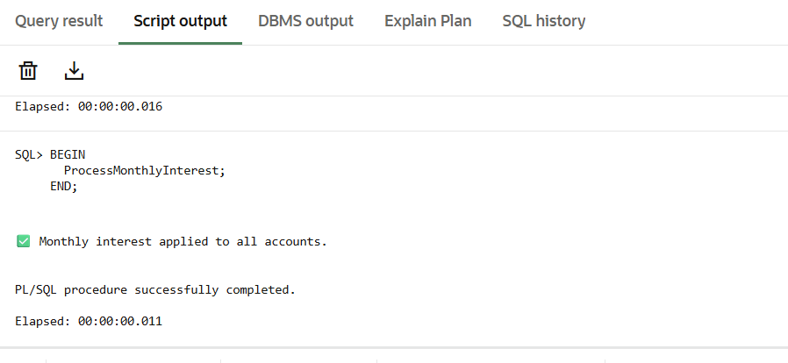

**Scenario 2: Procedure to Apply Bonus by Department:**

CREATE OR REPLACE PROCEDURE UpdateEmployeeBonus(

p_dept IN VARCHAR2,

p_bonus_percent IN NUMBER

) IS

BEGIN

UPDATE EMPLOYEES_PROC

SET Salary = Salary + (Salary * (p_bonus_percent / 100))

WHERE Department = p_dept;

DBMS_OUTPUT.PUT_LINE('✅ Bonus applied to department: ' || p_dept);

END;

/

BEGIN

UpdateEmployeeBonus('IT', 10); -- 10% bonus to IT

END;

/

**Output for Scenario 2:**

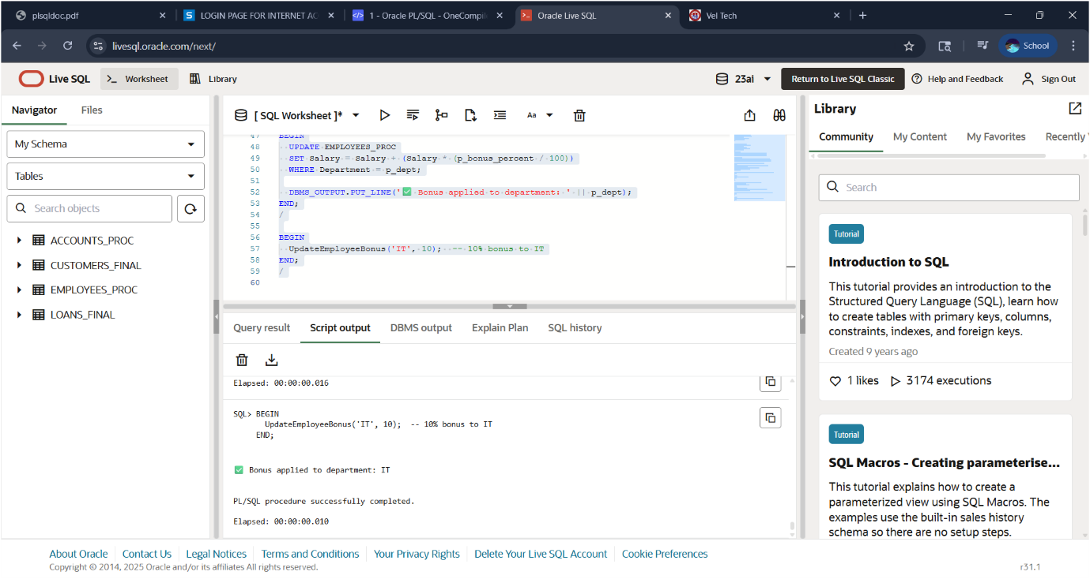

**Scenario 3: Transfer Funds Between Accounts**

CREATE OR REPLACE PROCEDURE TransferFunds(

p_from_acc IN NUMBER,

p_to_acc IN NUMBER,

p_amount IN NUMBER

) IS

v_balance NUMBER;

BEGIN

-- Check source balance

SELECT Balance INTO v_balance FROM ACCOUNTS_PROC WHERE AccID = p_from_acc;

IF v_balance < p_amount THEN

DBMS_OUTPUT.PUT_LINE('❌ Insufficient balance in source account.');

ELSE

UPDATE ACCOUNTS_PROC SET Balance = Balance - p_amount WHERE AccID = p_from_acc;

UPDATE ACCOUNTS_PROC SET Balance = Balance + p_amount WHERE AccID = p_to_acc;

DBMS_OUTPUT.PUT_LINE('✅ Transferred ₹' || p_amount ||

' from Account ' || p_from_acc ||

' to Account ' || p_to_acc);

END IF;

EXCEPTION

WHEN NO_DATA_FOUND THEN

DBMS_OUTPUT.PUT_LINE('❌ One or both account IDs not found.');

END;

/

BEGIN

TransferFunds(1, 2, 3000); -- Transfer ₹3000 from Acc 1 to Acc 2

END;

/

SELECT * FROM ACCOUNTS_PROC;

SELECT * FROM EMPLOYEES_PROC;

**Output for Scenario3:**

